Linux Practice with Holiday Hack

The Holiday Hack Challenge, or Kringlecon, is presented each year at Christmas time as a gift to the information security community. The 2020 version had a nice Linux Primer that we will use for practice.

# Log in to Kringlecon 2020

Go to <https://2020.kringlecon.com/invite> and click the image in the center, the click to register for KringleCon.

Once you create your account and log in, you will appear at a gondola near the New Jersey Turnpike that will magically take you to the North Pole. Enter the gondola. If your avatar looks too funky, you can change it using the settings button.

There are lots of fun challenges, but today we are interested in the Linux Primer that lives in the castle courtyard.  
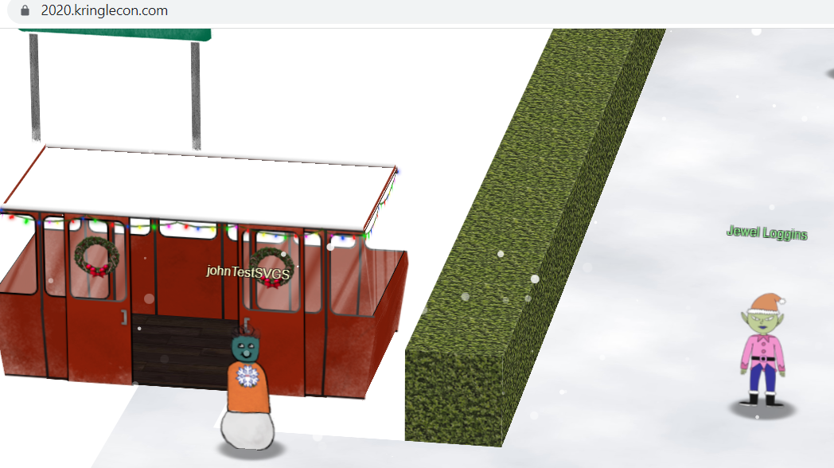

Enter the castle.

Go to the left to the Dining Room.  
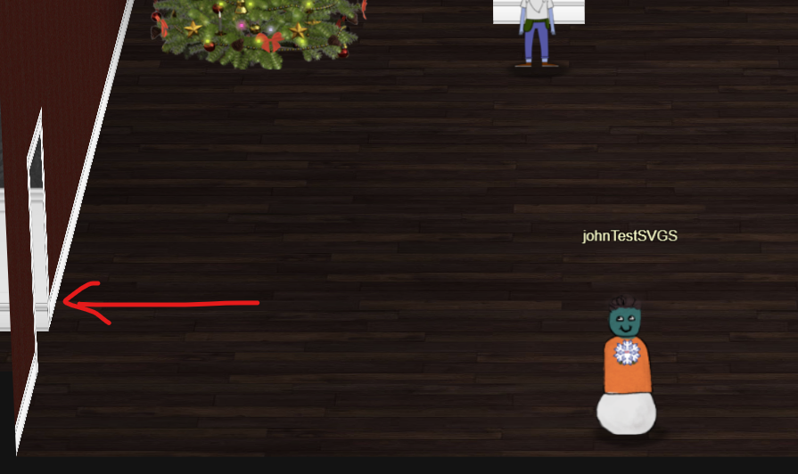

Then go out the door to the courtyard.  
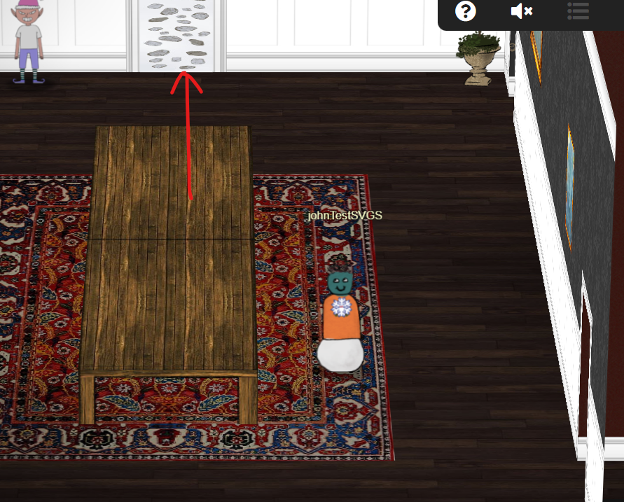

Go to the right to the Linux Primer and click on it.

Answer the questions in the Linux Primer terminal. If you get stuck, you can type hintme for a hint. You can always Google to look things up.

# Hand In

Submit a screenshot of the last screen to show you completed the primer.